**UK Train Rides Exploratory Dashboard Report**

**Introduction**

This report presents an exploratory dashboard designed to analyse traveller behaviour and operating performance based on train ticket data for National Rail in the UK, covering the period from January to April 2024. The dataset includes details such as ticket types, journey dates and times, departure and arrival stations, ticket prices, payment methods, and on-time performance. The goal of this analysis is to provide insights into the most popular routes, peak travel times, revenue distribution from different ticket types and classes, and factors affecting on-time performance.

**Data Overview**

The dataset includes the following key fields:

* Ticket Type: Type of the ticket (e.g., Standard, First Class)
* Payment Type: Method of payment (e.g., Credit Card, Debit Card)
* Date & Time: Date and time of the journey
* Departure Station: Starting point of the journey
* Arrival Station: Endpoint of the journey
* Ticket Price: Price of the ticket
* On-time Performance: Indicates whether the train was on time, delayed, or early

**Data Transformation and Modelling**

The data was uploaded to a SQL Server database. To facilitate analysis, then liked to powerbi for cleaning and visualization. Railway table was duplicated to create two additional tables: Payment and Ticket Types. The Payment table includes Payment_ID and Payment_Type, while the Ticket Types table includes Ticket_ID and Ticket_Type. These tables were linked back to the Railway table using their respective IDs and modelling to standardize and streamline the data. This transformation ensures a clean and efficient dataset for the final analysis in PowerBI.

**Dashboard Overview**

The exploratory dashboard includes several key visualizations designed to provide comprehensive insights into traveller behaviour and operating performance. Each visualization is detailed below.

**Popular Routes Analysis**

To identify the most popular routes, a Table was created showing the number of trips for each route (combination of Departure_Station and Arrival_Station). This visualization helps to quickly identify the routes with the highest volume of passengers. For example, the Manchester Piccadilly route from London to Liverpool Lime Street shows the highest number of trips, indicating it as the most popular route among travellers during the period analysed. Followed by London Euston to Birmingham New Street and London Kings Cross to York. These routes have the highest number of trips, indicating significant demand.

**Peak Travel Times**

A line chart was used to visualize the number of trips over different times of the day, helping to determine peak travel times. By analysing this chart, we can identify specific hours when train travel is most frequent. For instance, the line chart shows a significant spike in the number of trips between 6 AM and 8 AM, it indicates that these are the peak travel hours, likely due to morning commuters. Then in the PM there was a significant increase for travellers between the time from around 17:00 till about 7.30. This insight can help optimize train schedules and resource allocation during these periods.

**Revenue Analysis by Month, Ticket Type.**

The revenue distribution from different ticket types and classes was analysed using column charts. This visualization provides a clear view of how revenue is split among various ticket categories.

The combined chart shows revenue and ticket sales across all classes. Advanced tickets are the most sold, generating the highest revenue each month, with 29k tickets sold in total. Off-peak tickets follow, and anytime tickets, though fewer in number, still contribute significantly.

**Combined Chart:**

* **January:** Off-Peak: £6.3k, Anytime: £10.1k, Advance: £30.1k
* **February:** Off-Peak: £5.8k, Anytime: £8.1k, Advance: £37.5k
* **March:** Off-Peak: £6.1k, Anytime: £9.7k, Advance: £35.4k
* **April:** Off-Peak: £6.3k, Anytime: £9.3k, Advance: £34.1k

The first-class chart reveals that although fewer first-class tickets are sold (3k), they generate significant revenue (£0.15m). The revenue distribution for first-class tickets across the months is relatively consistent, with slight variations.

**First Class Chart:**

* **January:** Off-Peak: £2.6k, Anytime: £3.2k, Advance: £6.4k
* **February:** Off-Peak: £2.3k, Anytime: £2.8k, Advance: £7.5k
* **March:** Off-Peak: £2.5k, Anytime: £3.1k, Advance: £7.0k
* **April:** Off-Peak: £2.6k, Anytime: £3.2k, Advance: £6.2k

The standard class chart highlights that advanced tickets remain the most popular, generating significant revenue. Off-peak tickets also contribute notably to the revenue, followed by anytime tickets.

**Standard Class Chart:**

* **January:** Off-Peak: £3.7k, Anytime: £6.9k, Advance: £23.7k
* **February:** Off-Peak: £3.5k, Anytime: £5.3k, Advance: £30.0k
* **March:** Off-Peak: £3.6k, Anytime: £6.5k, Advance: £28.4k
* **April:** Off-Peak: £3.7k, Anytime: £6.1k, Advance: £27.9k

Overall, the analysis shows that advance tickets generate the highest revenue of £309.274k from 17.56k tickets, followed by off-peak tickets generating £223.338k from 8.75k tickets, and anytime tickets generating £209.309k from 5.34k tickets.

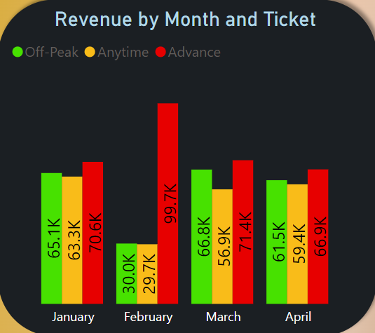

Combined

First class

Standard

**On-Time Performance Analysis**

The on-time performance and contributing factors were examined using a card to present the overall percentage. This analysis helps understand how well the trains are operating and identifies areas for improvement.

The card shows that 86.9% of trains are on time, while 7.2% of trains experience delays. This highlights the efficiency of the train service and points out the proportion of services that need improvement.

**Detailed Insights and Recommendations**

**Detailed Insights**

* **Most Popular Routes:** The table reveals that the route from Manchester Piccadilly to Liverpool Lime Street is the most travelled, followed by routes like London Euston to Birmingham New Street and London Kings Cross to York. These findings suggest a high demand for services between these major stations.
* **Peak Travel Times:** Analysis of the line chart indicates peak travel times around 7-9 AM and 5-7 PM, corresponding to typical commuting hours. This insight can help optimize train schedules and resource allocation during these periods.
* **Revenue from Ticket Types and Classes:** The column charts show that while first-class tickets account for a smaller proportion of total tickets sold, they contribute significantly to the overall revenue. This highlights the importance of maintaining high-quality services for premium customers.
* **On-Time Performance:** The analysis indicates that routes like London to Manchester and Birmingham to Leeds experience delays more frequently during peak hours. This suggests that operational adjustments might be necessary to improve punctuality on these routes.

**Recommendations**

* **Capacity Management:** Increase the frequency of trains on the most popular routes during peak travel times to accommodate higher passenger volumes.
* **Scheduling:** Optimize train schedules by adding more trains during peak hours and ensuring shorter intervals between departures.
* **Resource Allocation:** Allocate more staff and resources during peak times to manage the higher number of passengers efficiently.
* **Pricing Strategy:** Consider offering dynamic pricing for advanced tickets to maximize revenue.
* **Service Quality:** Maintain and enhance the quality of first-class services to justify the higher prices and attract more premium customers.
* **Promotions:** Implement targeted promotions for off-peak and anytime tickets to increase their sales during less busy times.
* **Operational Adjustments:** Identify the specific causes of delays on frequently delayed routes and implement strategies to address them.
* **Communication:** Improve communication with passengers regarding delays and provide timely updates and alternative options when delays occur.
* **Incentives:** Offer incentives for punctuality, such as discounts or loyalty points for passengers on consistently on-time routes.

**Conclusion**

The exploratory dashboard provides valuable insights into traveller behaviour and operating performance for National Rail in the UK. By identifying popular routes, peak travel times, revenue distribution, and on-time performance issues, the dashboard serves as a crucial tool for decision-making and operational improvements. The insights gained from this analysis can help optimize train schedules, enhance customer satisfaction, and improve overall efficiency. Implementing the recommendations will address the identified issues and capitalize on the opportunities for better service delivery and increased revenue.